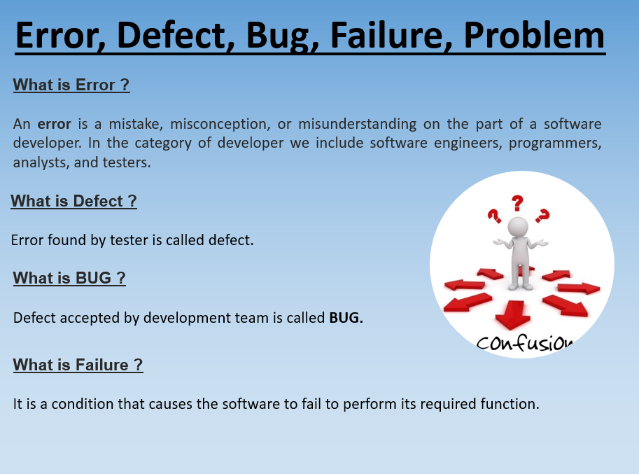

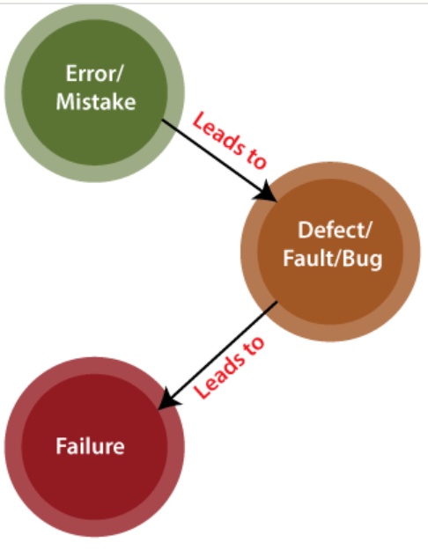

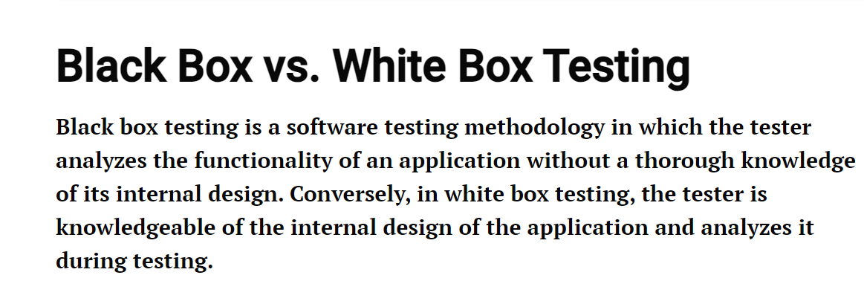

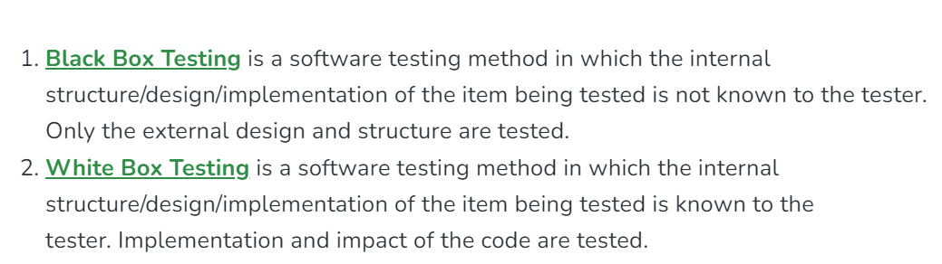

| **Black Box Testing** | **White Box Testing** |
| --- | --- |
| It is a way of software testing in which the internal structure or the program or the code is hidden and nothing is known about it. | It is a way of testing the software in which the tester has knowledge about the internal structure or the code or the program of the software. |
| Implementation of code is not needed for black box testing. | Code implementation is necessary for white box testing. |
| It is mostly done by software testers. | It is mostly done by software developers. |
| No knowledge of implementation is needed. | Knowledge of implementation is required. |
| It can be referred to as outer or external software testing. | It is the inner or the internal software testing. |
| It is a functional test of the software. | It is a structural test of the software. |
| This testing can be initiated based on the requirement specifications document. | This type of testing of software is started after a detail design document. |
| No knowledge of programming is required. | It is mandatory to have knowledge of programming. |
| It is the behavior testing of the software. | It is the logic testing of the software. |
| It is applicable to the higher levels of testing of software. | It is generally applicable to the lower levels of software testing. |
| It is also called closed testing. | It is also called as clear box testing. |
| It is least time consuming. | It is most time consuming. |
| It is not suitable or preferred for algorithm testing. | It is suitable for algorithm testing. |
| Can be done by trial and error ways and methods. | Data domains along with inner or internal boundaries can be better tested. |
| **Example:** Search something on google by using keywords | **Example:** By input to check and verify loops |
| **Black-box test design techniques-**   * Decision table testing * All-pairs testing * Equivalence partitioning * Error guessing | **White-box test design techniques-**   * Control flow testing * Data flow testing * Branch testing |
| **Types of Black Box Testing:**   * Functional Testing * Non-functional testing * Regression Testing | **Types of White Box Testing:**   * Path Testing * Loop Testing * Condition testing |
| It is less exhaustive as compared to white box testing. | It is comparatively more exhaustive than black box testing. |

It is performed by Developers, and then the software will be sent to the testing team, where they perform black-box testing. The main objective of white-box testing is to test the application's infrastructure.

